

**Artificial Intelligence and Data Science Department.**

OS / Even Sem 2021-22 / Experiment 6.

**___________________________________________________**

YASH SARANG.

47 / D6AD.

EXPERIMENT - 6.

CPU Scheduling.

**___________________________________________________**

**Aim:** Write a program to demonstrate any three CPU scheduling algorithms like FCFS, SJF (preemptive and non preemptive), Round Robin, priority(preemptive and non preemptive) .

**___________________________________________________**

**Theory:**

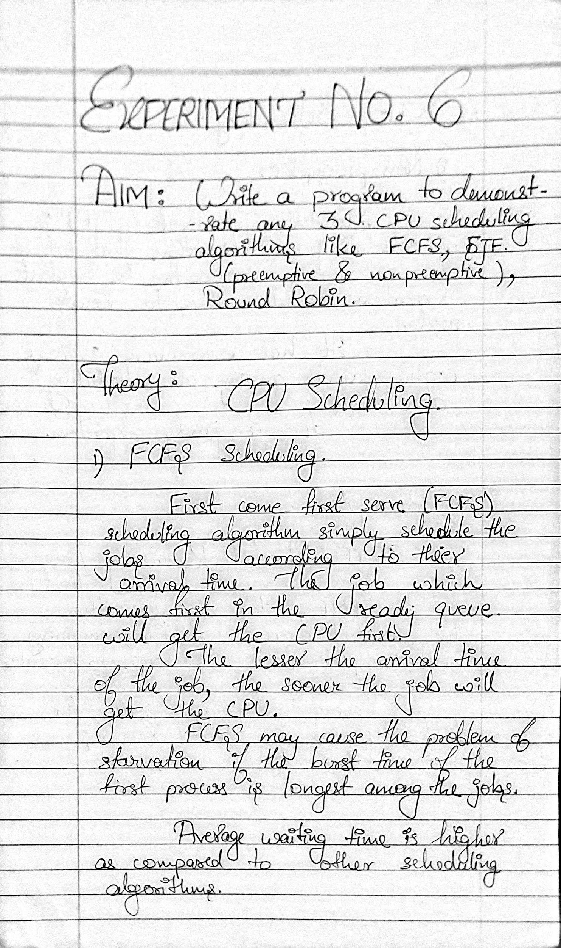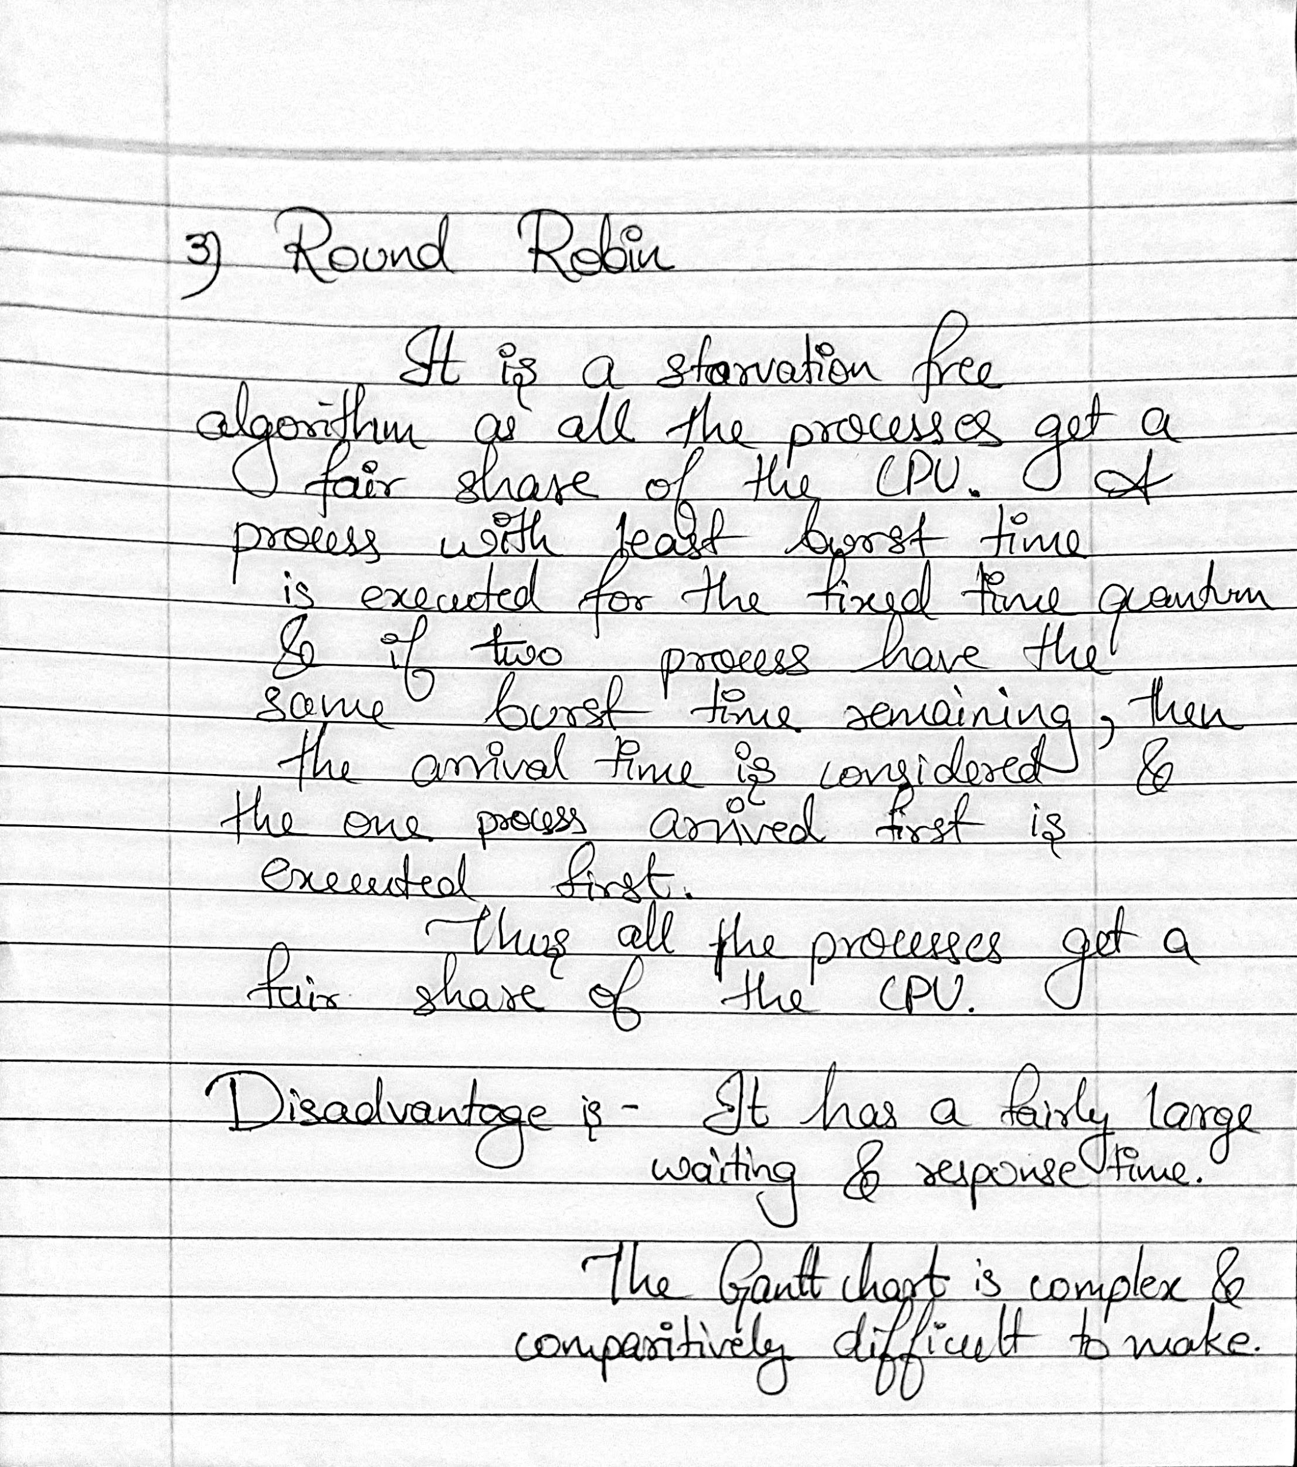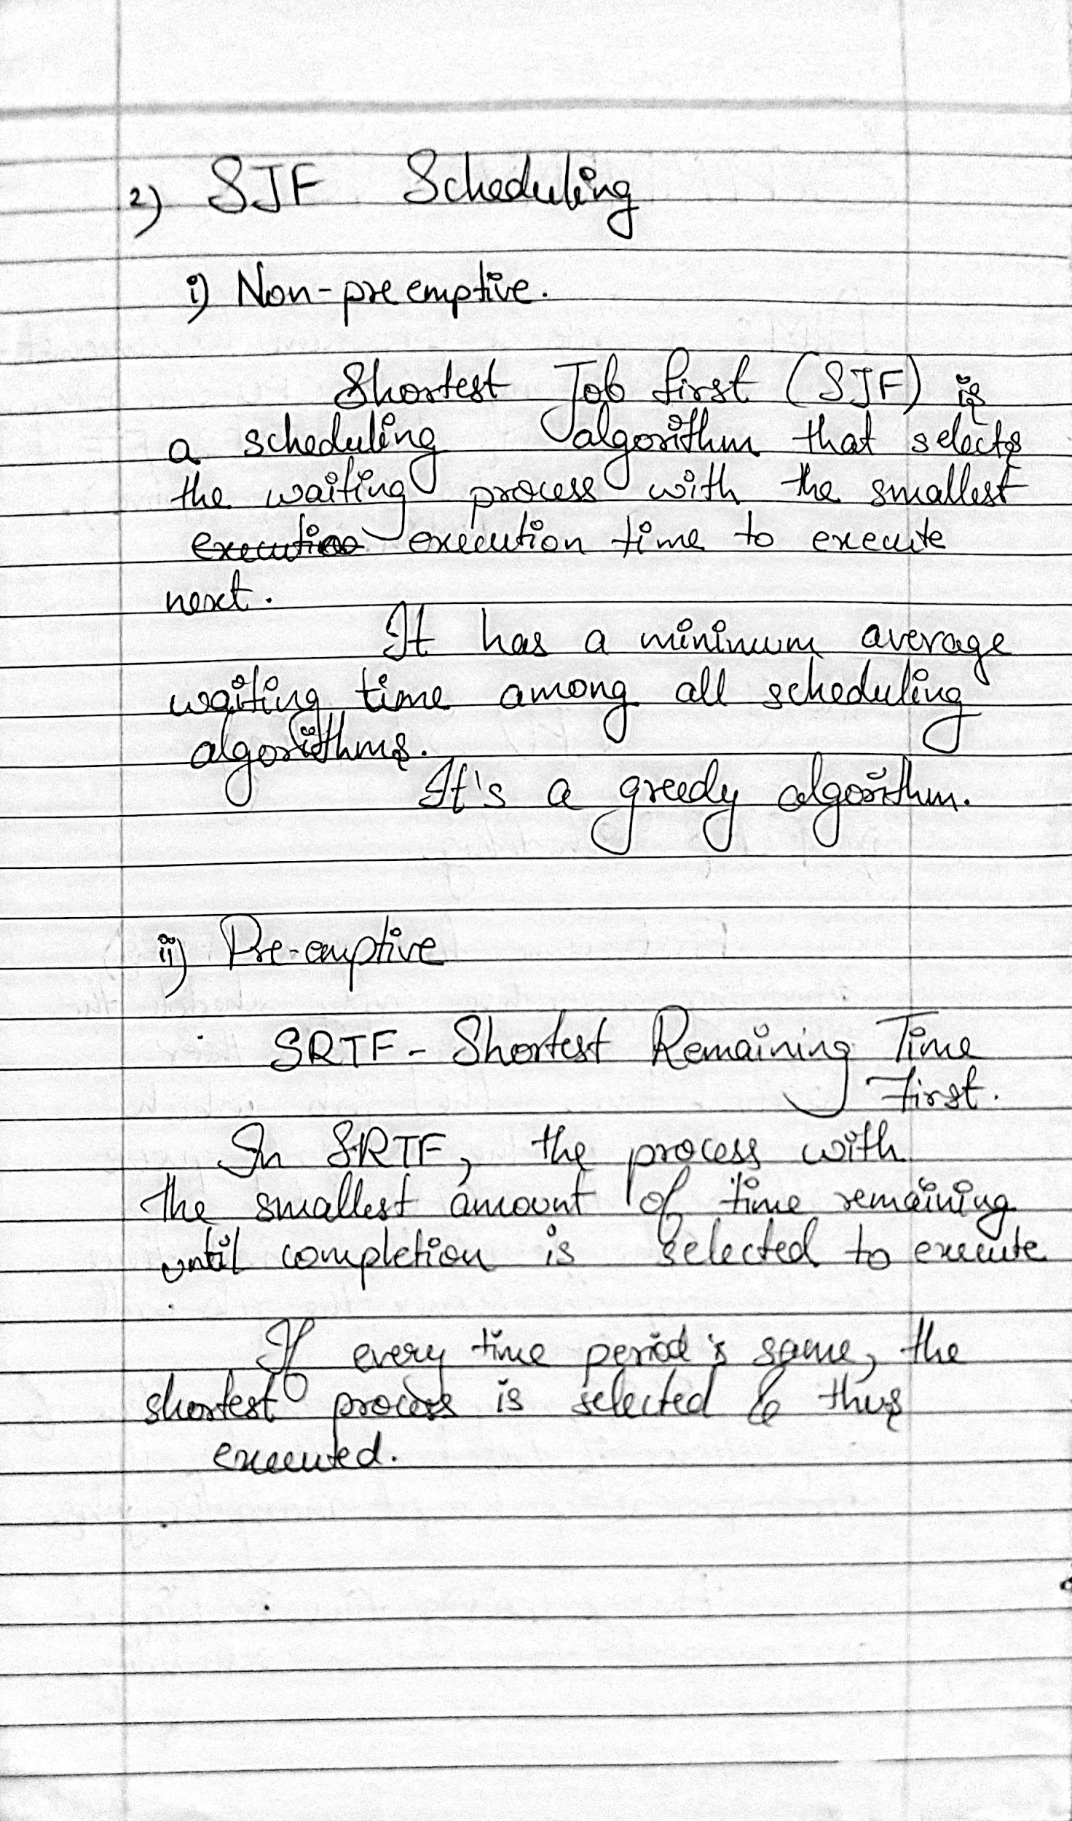

**___________________________________________________**

**Snippets:**

1. FCFS:

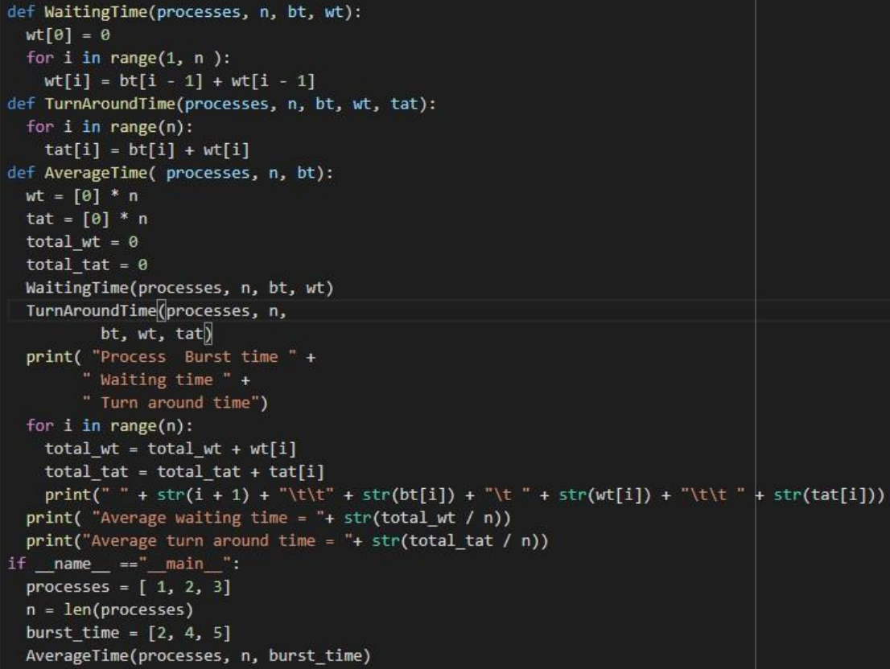

Output:

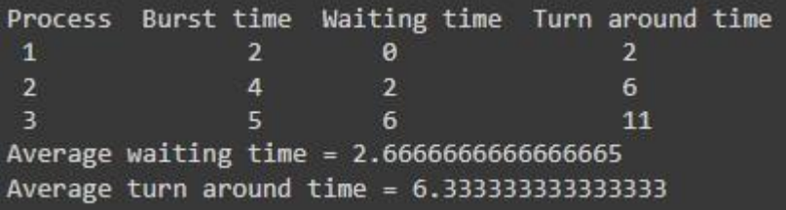

**___________________________________________________**

2. SJF (Non-Pre emptive)

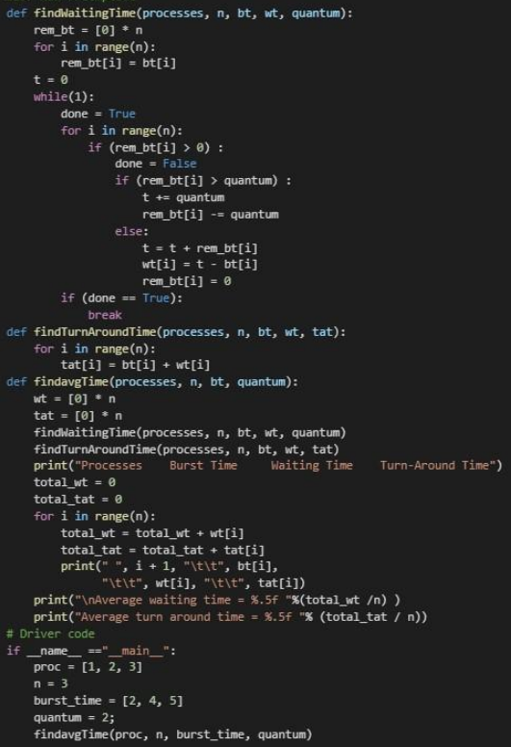

Output:

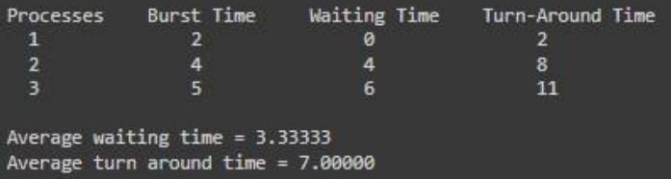

**___________________________________________________**

3. SRTF (Pre-emptive)

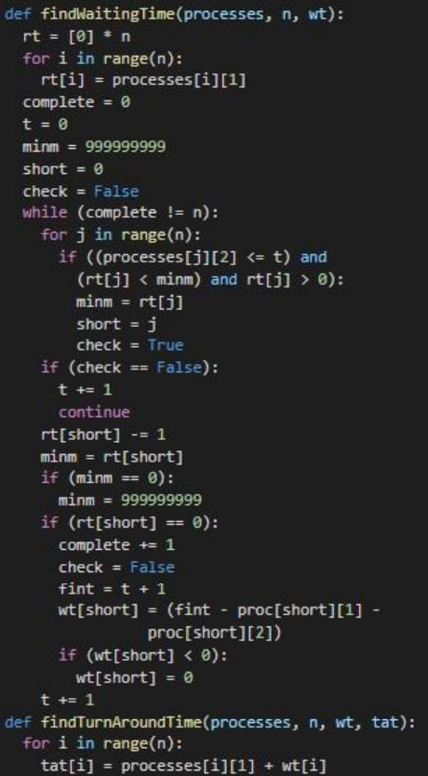

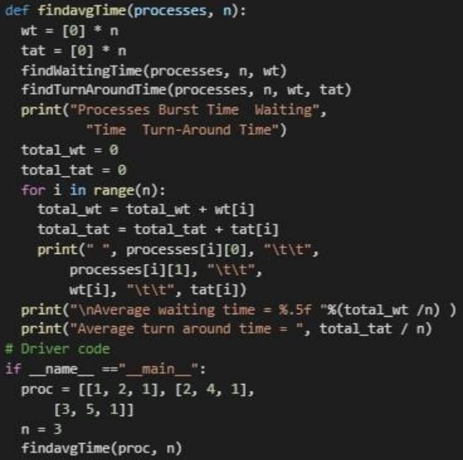

Output:

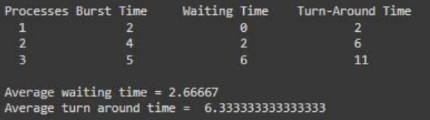

**___________________________________________________**

4. Round Robin

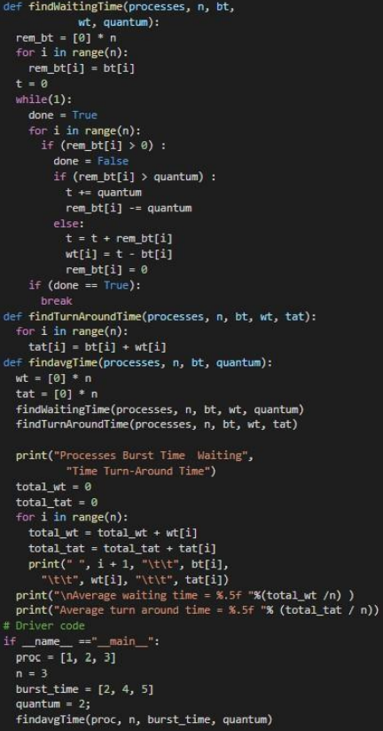

Output:



